ICN2

# Preprocessing

1. On SaleCondition column, aggregating condition other than normal to abnormal
2. Ordinal encoder on transforming ['Neighborhood', 'HouseStyle', 'SaleCondition'] columns
3. SimpleImputer on missing data ['LotFrontage', 'LotArea', 'TotalBsmtSF', 'GrLivArea', 'GarageCars', 'SalePrice']

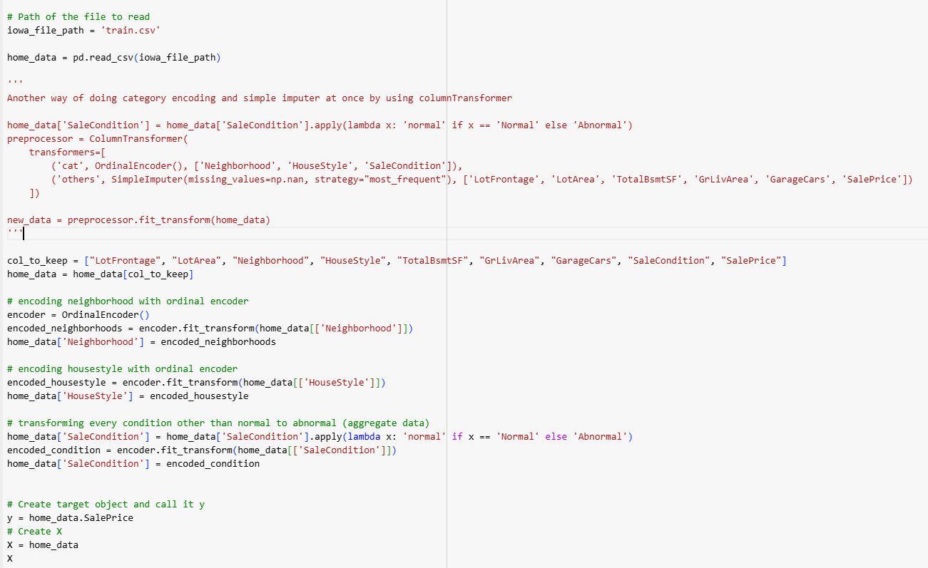

Output:

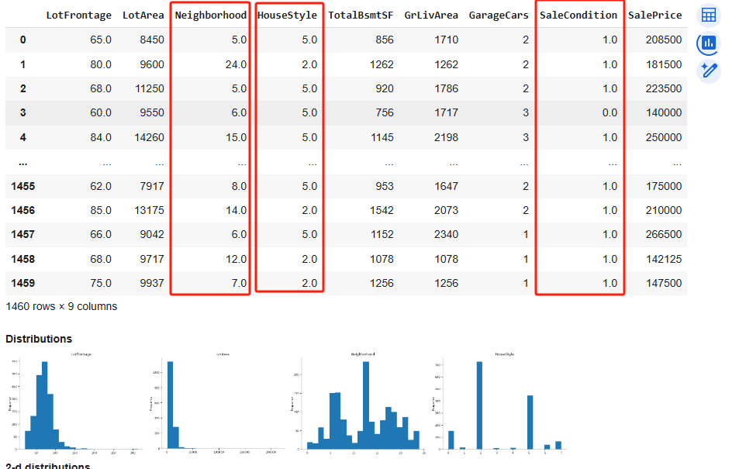

# Training and Evaluation

Tried evaluating MAE on both max_leaf_nodes no specifying model and max_leaf_nodes = 100 model. The MAE result is satisfying. Best MAE of 692.

Tried cross validation with 10-fold. The rmse score is shown below

Output:

